1. **Agenda**:
   1. Going to set up Kafka Consumer Configuration in application.yaml file using Spring Boot Auto-Configuration concept.
2. 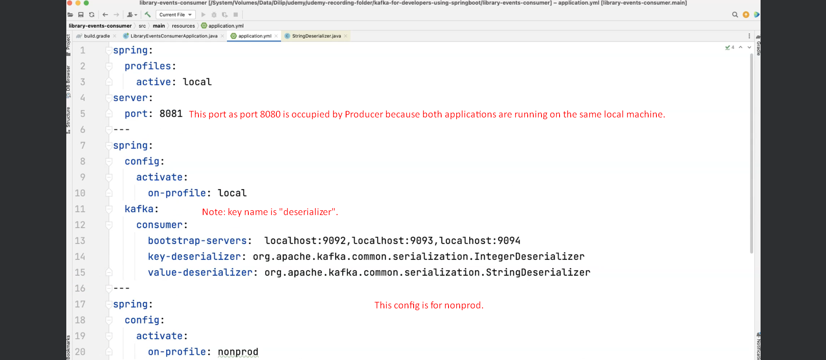  
   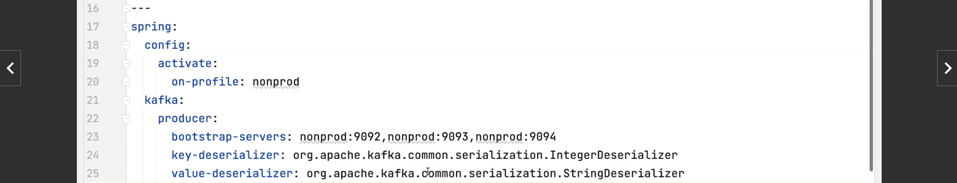
3. 